Requirement Analysis

Data Flow Diagrams & User Stories

Date | 06 November 2025
Team ID | F529277D47452DB9E7447BD087E08E5E
Project Name | Medical Inventory Management
Maximum Marks | 4 Marks

Level 0 (Context Diagram)
Main Entities:
- Admin / Inventory Manager
- Supplier
- Hospital Departments / Staff
- System Database
Data Flows:
- Admin manages product stock (add, update, remove).
- Supplier provides inventory and delivery details.
- Hospital staff request medical items.
- System generates alerts, reports, and updates stock automatically.
Diagram Description:
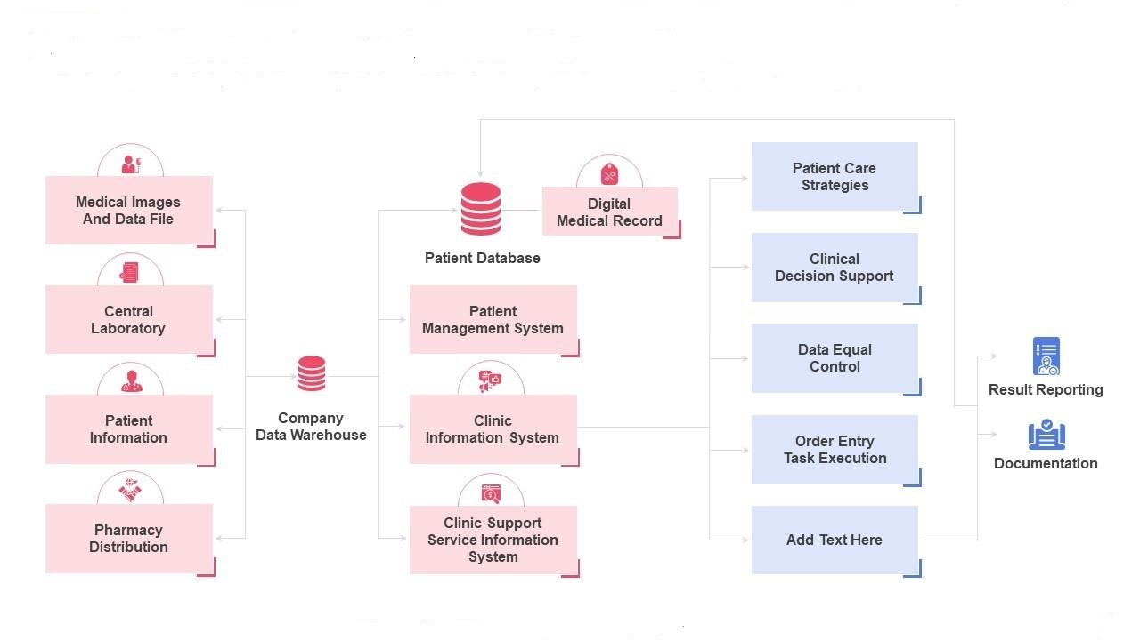

Level 1 DFD (Expanded System View)
Processes:
- Manage Inventory
  - Add new items, update quantities, mark expiry dates.
- Handle Requests
  - Department requests items; system checks availability.
- Supplier Management
  - System sends purchase orders to suppliers.
- Generate Reports
  - Monthly usage, low-stock alerts, expired stock.
Data Stores:

D1: Inventory Database

D2: Supplier Records

D3: Request Log
Data Flow Example:
[Admin] ---> (1) Manage Inventory ---> [Inventory Database]
[Department] ---> (2) Handle Requests ---> [Request Log]
(2) Handle Requests ---> (3) Supplier Management ---> [Supplier]
(1) Manage Inventory ---> (4) Generate Reports ---> [Admin]

Level 2 DFD (Detailed Flow Example — "Handle Requests")
Processes:
- Check Item Availability
- Approve or Deny Request
- Update Inventory Records
Flow Example:
[Department] --> (1) Check Availability --> [Inventory Database]
--> (2) Approve Request --> [Admin]
--> (3) Update Inventory --> [Inventory Database]

User Stories
User stories describe what each user needs from the system — following the “As a [user], I want [goal], so that [benefit]” format.

A. Admin / Inventory Manager

As an admin, I want to add and update stock items so that inventory data stays current.

As an admin, I want to view low-stock alerts so that I can reorder before shortages occur.

As an admin, I want to generate usage and expiry reports so that I can manage waste effectively.

As an admin, I want to assign suppliers to products so that I can streamline ordering.

B. Hospital Staff / Department User

As a staff member, I want to request medical items online so that I can quickly get what I need.

As a staff member, I want to track my request status so that I know when items will arrive.

As a staff member, I want to view available inventory so that I can plan my usage.

C. Supplier

As a supplier, I want to receive purchase orders digitally so that I can process them faster.

As a supplier, I want to update delivery status so that the hospital knows when to expect stock.

D. System (Automatic Features)

As a system, I want to send alerts for expired medicines so that the admin can take timely action.

As a system, I want to auto-update stock after each transaction so that records remain accurate.

Optional Add-ons
You can also include:
- ER Diagram (for database structure)
- UML Use Case Diagram
- Sequence Diagram (for request & approval flow)
- Activity Diagram (for stock management process)

